PRACTICAL NO. 10

10. Configuring ASA Basic Settings and Firewall Using CLI

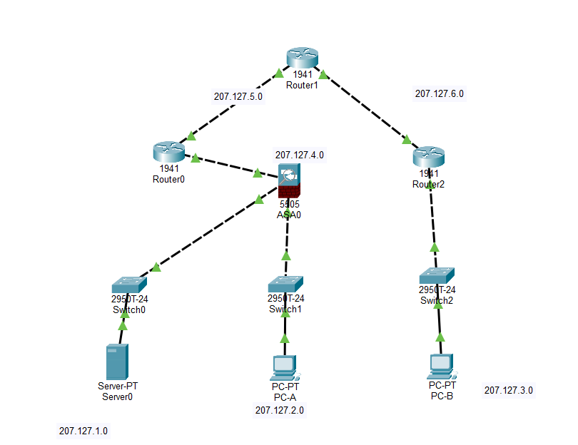

Step 1 : Configure basic ASA settings and interface security levels using CLI
OSPF for routers

Ping Roters R0,R1,R2 from PC B
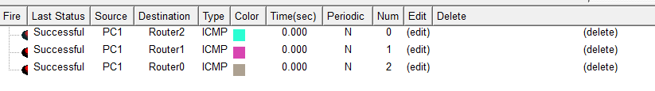

Step 2 : Configure routing, address translation, and inspection policy using CLI
Set Clock
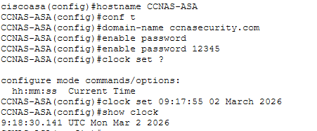

Created invlan and outvlan vlan

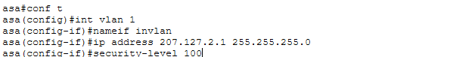

Interface IP brief:
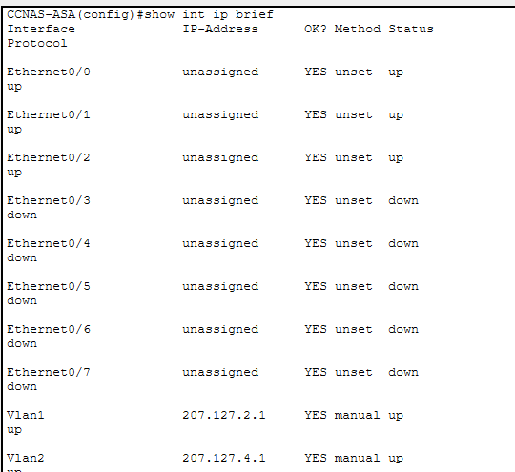
Show IP Address
s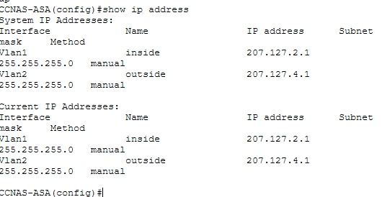
Show Switch vlan
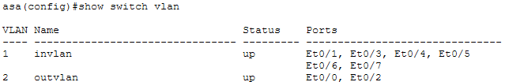

Show IP Address
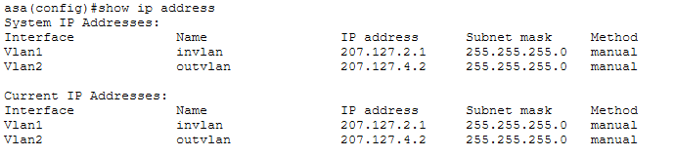
Create network object inside-net
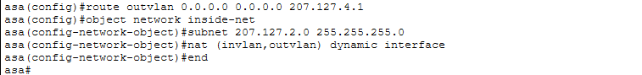
Inspection global service policy
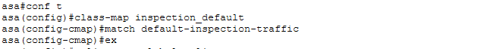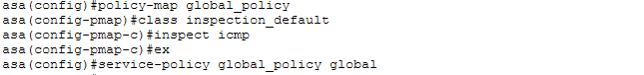
From PC-A to Outside R1

C. Configure DHCP, AAA, and SSH
Configure DHCP
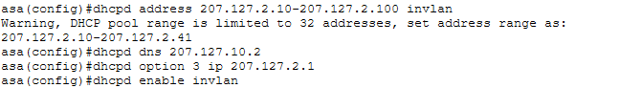Checking dhcp:
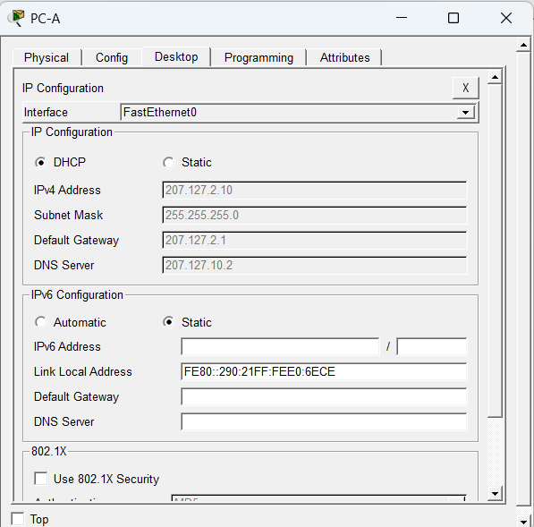

AAA and SSH:
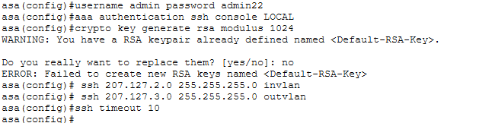

Accessing ASA using SSH from PC-A
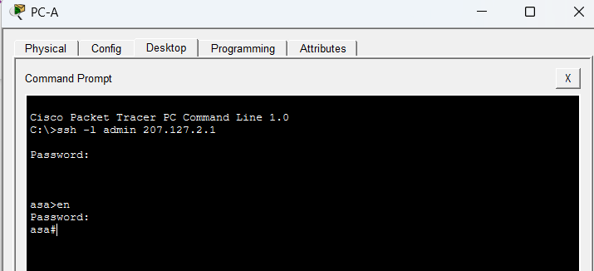
Accessing ASA using SSH from PC-B
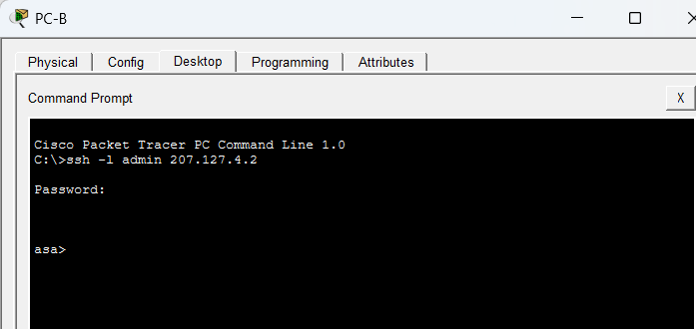

D. Configure a DMZ, Static NAT, and ACLs
Create vlan 3:
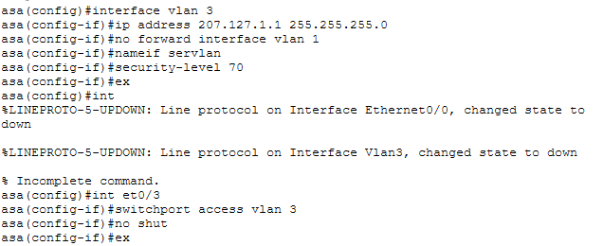

Address:
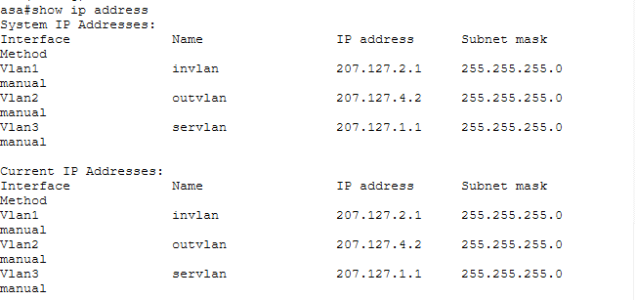

Configure static nat and DMZ server
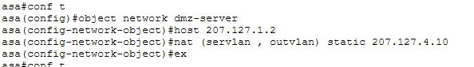

Configure an ACL to allow access to the DMZ server from the internet
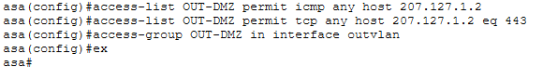

OUTPUT:
